

Parkside Medical Centre - Service Guide



|  |
| --- |
| **Parkside Medical Centre - Site Details**  **T: 020 7703 0596**  **52 Camberwell Green, London, SE5 7AQ**  **W: www.parksidemedical.co.uk**  **E: souccg.ParksideMC@nhs.net** |
|  |

# Welcome to the Parkside Medical Centre

## Welcome

At Parkside Medical Centre, we aim to treat all our patients promptly, courteously and in complete confidence. This leaflet is for both existing patients and those considering registering with us. It tells you about our services, how to access them and some general information about how our Practice operates.

## Opening Hours

|  |  |
| --- | --- |
| Monday  Tuesday  Wednesday  Thursday  Friday | 8.00am – 8.00pm  8.00am – 6.30pm  8.00am – 8.00pm  8.00am – 6.30pm  7.00am – 6.30pm |

## Out of Hours telephone number: 111

When the Practice is closed the Out of Hours Service, provided by SELDOC, is available for urgent problems that cannot wait until the Practice reopens. For emergency situations patients should dial 999

Community GP appointments can be accessed at the Tessa Jowell Health Centre via the extended Primary Care Access Hub. These appointments can be booked by the Parkside Practice team for acute needs if a suitable appointment is not available at the practice.

**Business Practice Manager**

Golam Morshed has overall day-to-day responsibility for the surgery. He will ensure that the services are running smoothly, and will manage the team of clinicians and administrators at the Parkside Medical practice.

**Doctors**

Dr. Azra Parvez, MBBS LRCP MRCS MRCGP GP Trainer and clinical lead (Female)

Dr Nynke Arscott, General Practitioner (Female)

Dr Yee-Jun Lim, General Practitioner (Male)

Dr Luke Twelves, General Practitioner (Male )

Melissa Chiu , Registrar ( Female )

*Parkside Medical Centre is an accredited training practice*

The Clinical team at the Parkside Medical Centre are led by the clinical lead.

**Nurse Practitioners and Nurses**

Nurse Practitioner: Yvonne Cole (Female)

Practice Nurse: Bridget Dodwell (Female)

**Practice Paramedic**

Robert Kemp (Male)

**PCN Pharmacist**

Kajal Haghmoradi (Female)

**Healthcare Assistant**

Health Care Assistant: Reaz Ahmed (Male)

### Administrative Team

The team is your main point of contact when you use our services and are always there to help. They may need to ask you medical details in order to assist you and help direct you to the most appropriate clinician and at all times are working under the instructions of the doctors. All information given to them is treated in confidence. The more information you are able to give to the team the better they will be able to assist you.

# How to Register

If you live within the catchment area outlined below you can register with us today and we will contact, you to arrange a full health check and introduce you to our Practice. For a detailed map of our catchment area please visit **www.parksidemedical.co.uk**

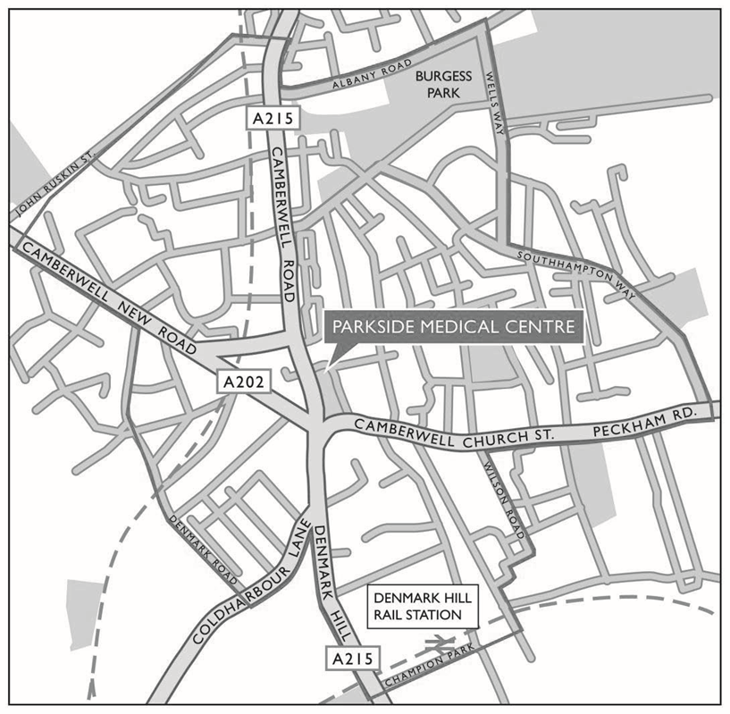

**Registering is Easy**

New patients can register in a number of ways:

* **At the practice -** pick up a registration form from the reception area and our staff can help you with any queries you may have.
* **Online** - Visit **www.parksidemedical.co.uk** where you can complete the online form expressing your interest to become a registered patient. We will then contact you to complete the final stage of registration.

In order to register at the Parkside Medical Centre please ensure you bring with you proof of your address (such as a utility bill or bank statement), photo ID (such as passport or driving license) and your NHS medical card (if you have one). We will not be able to register you without your proof of identity. Alternative forms of identification will be considered as we work with patients to make the process as simple as possible.

Once registered we will arrange for you to have a brief health check with a practice nurse or health care assistant at a time convenient to you. This will give you an opportunity to discuss any health concerns and enables us to learn more about your health needs.

# Services

## Pre bookable Appointments

You can book an appointment with either a clinician for up to 4 weeks in advance. If you have a preferred clinician that you would like to see, please let us know when you book your appointment. Please note, patients may not always be able to see their preferred practitioner as they may not hold surgeries every day or they may be absent from the Practice (e.g. on annual or study leave).

To make an appointment please contact reception on **020 7703 0596.**Our routine appointment time is 10 minutes per appointment per patient for a doctor or ANP and 15 minutes for a practice nurse; appointment times may vary depending on the situation.

If you are able to inform the receptionist about the nature of your appointment, they will be better able to allocate the correct appointment time for you. Please restrict your appointment to a maximum of one medical issue per appointment. If you have more issues you will need additional appointments.

The practice staff ensure patient confidentiality is maintained at all times, however for the effective functioning of a multi-disciplinary team it is sometimes necessary that relevant medical information is shared between members of the Practice team.

## Same Day Appointments

We offer a same day appointment service for patients Monday to Friday. A patient can call to the Practice at 8 am for a same day appointment.

#### Telephone Consultations

Many problems can be sorted out over the telephone without face-to-face contact with a doctor. Advice can be given and prescriptions issued. If you would like to speak to a doctor regarding a non-urgent issue, please request a telephone consultation.

**Home Visits**

Please make your request for a home visit before 10.30am if possible. Most problems are best dealt with at the surgery as all the necessary staff and equipment are based there. Please do let the receptionist know what the problem may be in order to enable him or her to alert the doctor to the urgency of your call. A doctor may call you back to discuss where it is best to see you. To request a home visit please call us on: **020 7703 0596**

#### Cancelling Appointments

Please ensure that you cancel any appointment that you no longer require at least one hour before the appointment time this will enable us to offer this to another patient. Call us on:**020 7703 0596** or use the cancellation on the text reminder.

Please remember if you do not attend your appointment and have not notified us that you are not attending you are preventing another patient from using that appointment. Patients who repeatedly fail to attend appointments may be asked to register with another practice.

#### Disabled Access

All patient services are available at ground floor level but if any assistance is required please ask at reception and a member of staff will be glad to help

**Online patient access services**

If you are a registered patient of the practice, an online service is available to you which is offered by our clinical computer system (EMIS) to allow you to perform the following tasks online.

* Online Appointment Booking
* Order Repeat Prescriptions
* Change Your Contact Details

More information on this service is available by accessing the online services section of the practice website.

**Online Appointment booking**

As a registered patient of the Practice, you are able to view, book and cancel appointments from home, work or on the move – wherever you can connect to the internet

**Repeat Prescriptions**

There are many options available to order your repeat prescription; you can tick the appropriate medication on your computerised slip to hand it in at reception or send it to the practice via post or e-mail us at [souccg.parksideMC@nhs.net](mailto:souccg.parksideMC@nhs.net)

Patients who receive regular prescriptions from the practice can request a repeat prescription from the practice by logging onto the Patient online access system (please provide your full name, address, date of birth and a list of your repeat medications) and selecting the drugs that are required. The Doctor will review the request and either accepts or declines the request and the patient is notified.

If you wish to collect your repeat prescription from a local pharmacy please indicate which pharmacy. You will need to allow up to 72 hrs before you can collect your medication from the pharmacy. In order to register, you will need to contact our reception team and they will explain the information you require to register for online access. Some local pharmacies provide a free delivery service to those who need it.

If you would like us to send your prescription to you by post, please provide a self-addressed envelope. Please ensure you allow two full working days for us to prepare your prescription. You may be required to attend a medication review before your repeat can be issued. To avoid any errors we do not take any repeat prescription requests via the telephone.

**Medical Records**

Patients of the Practice who have registered for online services are able to have secure online access to relevant parts (Current medications, immunisations and allergies) of their medical records.

**Registering for Patient Access**

You can access the system by accessing the following links:

<https://www.nhs.uk/using-the-nhs/nhs-services/the-nhs-app/>

<http://www.patient.co.uk/access>

#### Repeat Dispensing Scheme

If you are on regular medication your doctor can issue several prescriptions in advance to be held and distributed when you need them by your chosen pharmacy. This saves the patient time and inconvenience when ordering and collecting prescriptions.

#### Statements of Fitness for Work

Sickness Certificates for periods of less than 7 days should be signed by the patient themselves, in the form of a self-certification Form (SC2), available from your employer, GP or online at <https://www.gov.uk>

We will issue, free of charge, a Statement of Fitness for Work (sick certificate) to registered patients for whom we provide clinical care. A statement will not be issued to a patient until they have been off work for more than 7 calendar days. DSS certificates of incapacity are free and GP discretion see Non NHS Services.

#### Travel Medicine

We provide an advice and immunisation service to meet your travel needs. Please check your requirements with us as soon as you make your travel plans as some medicines require several courses. Travel advice is available from [www.fitfortravel.nhs.uk](http://www.fitfortravel.nhs.uk). Please note that not all travel vaccinations are available free on the NHS, there may be a charge for any immunisations you require to travel.

#### Test Results

Please note that the receptionist can only give results to patients once the Doctor has checked the results and given authorisation. In order to maintain patient confidentiality, results can only be given to the patient themselves.

Parents of patients under 16 can request results on the child’s behalf.

Most blood, urine and swab tests take up to two weeks to be processed and completed by the laboratory, these are then sent back to the surgery for review by your clinicians.

Patients are kindly asked to contact the surgery, after 2pm, two weeks after taking the test. The administrator will read back to you any comments that the clinicians have made and assist you with any follow up appointments, if required. If you have previously arranged a follow up appointment with your clinician you do not need to ring for the results.

#### Specialist and Hospital care

If a GP or another member of our healthcare team believes you need hospital treatment or specialist care elsewhere, this can be organised on your behalf. If you prefer to consider where and when you would like to arrange your appointment, you can be given a reference number and will be able to book the appointment yourself.

#### Non NHS Services & Private Fees

Certain services provided by your doctor are not covered by the NHS and you may be asked to pay a fee. These include:

* A Pre-employment Medical
* A Private Medical
* An Insurance Claim
* A Fitness To Drive Medical
* Travel immunisations
* Certain occupational vaccinations

Please call:**020 7703 0596** for more information or speak to a member of our administration team.

# Medical Records & Confidentiality

All patient records are confidential. All our staff are trained in accordance with the Data Protection Act and work under strict rules of confidentiality.

## Freedom of Information Act (2000)

From 1 January 2005, you can ask any public authority for information they hold. Public authorities will provide you with the information unless there is a good reason for not doing so.

## How We Use Your Records

The people who care for you use your records to:

* Provide a good basis for all health decisions made by you and care professionals
* Allow you to work with those providing care
* Make sure your care is safe and effective, and
* Work effectively with others providing you with care

**Others may also need to use records about you to:**

* check the quality of care (such as clinical audit)
* protect the health of the general public
* keep track of NHS spending
* manage the health service
* help investigate any concerns or complaints you or your family have about your health care
* teach health workers and
* help with research

Some information will be held centrally to be used for statistical purposes. In these instances we take strict measures to ensure that individual patients cannot be identified. We use anonymous information, wherever possible, but on occasions we may use personally identifiable information for essential NHS purposes such as research and auditing. However, this information will only be used with **your consent,** unless the law requires us to pass on the information. More information about how your information is used can be found on the practice website under the link to **privacy notices**.

## Changes to Personal Details

Please notify the surgery of any changes in your personal details such as your name, address or telephone number. This will enable us to keep our records up to date. This is very important as we may need to contact you at short notice.

# Patient Rights and Responsibilities

You have a right to expect a high standard of medical care from our practice and we will try at all times to provide the very best care possible within the resources available.

In order to assist us in this, we require that you take full responsibility for ensuring that you do not abuse the service. It is your responsibility to ensure that you keep appointments, on time, and follow the medical advice given. Please restrict your appointment to a maximum of one medical issue per appointment. If you have more issues you will need additional appointments.

Parkside Medical Centre operates a zero tolerance policy. We will not tolerate any violent behaviour or abuse towards any member of our team. Any such behaviour will result in removal from our list.

## Patient Participation Group

This group is run by a committee of patients for the benefit of the Practice and Patients. **This is your group** so please ask how you can contribute your ideas.

## Complaints

Should you wish to make a complaint about our service in the first instance, please ask to speak to a manager/supervisor.

Alternatively, you can put your complaint in writing to the Practice Manager. If the Practice cannot resolve the issue or should you be dissatisfied with the outcome you also have the right to approach the following:

**Independent Complaints Advocacy Service**: 0300 456 2370

Web: [www.pohwer.net](http://www.pohwer.net)

**The Parliamentary Ombudsman**: 0345 015 4033

Web: [www.ombudsman.org.uk](http://www.ombudsman.org.uk)

**NHS England**: 0300 311 22 33

Email: [England.contactus@nhs.net](mailto:England.contactus@nhs.net)

This medical practice is operated by **Omnes Healthcare General Practice Limited Ltd.**

Registered in England and Wales No. 05418732

Registered address: Alexandra House, 43 Alexandra Street, Nottingham, NG5 1AY *e time of printing*